**Time Complexity of Graham Scan Algorithm:**

Time complexity of Graham Scan algorithm is always $O(nlogn)$ irrespective of the input. $O(nlogn)$ time is needed while sorting the vertices according to their angle with the most bottom-right vertex.

***Graham Scan* performs better than *Gift Wrapping*:**

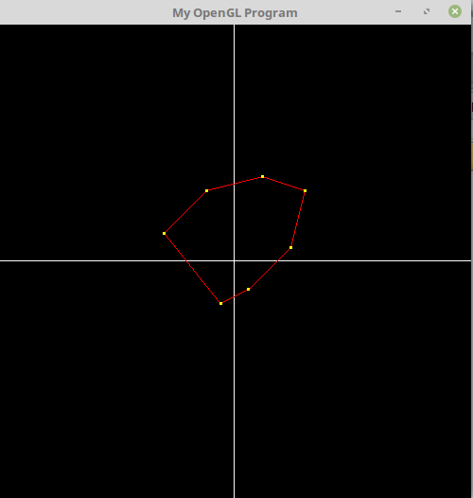

Graham-Scan: $O(nlogn)$

Gift-wrapping: $O(n{}^{2})$

***Graham Scan* performs worse than *Gift Wrapping*:**

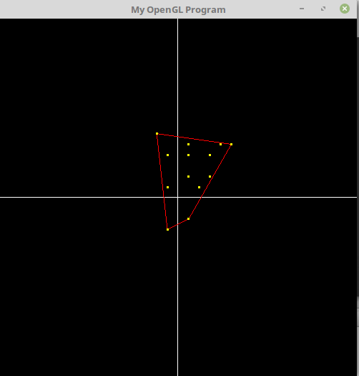

Graham Scan: $O(nlogn)$

Gift-wrapping: $O(4n)$

***Graham Scan* performs better than *Quick Hull*:**

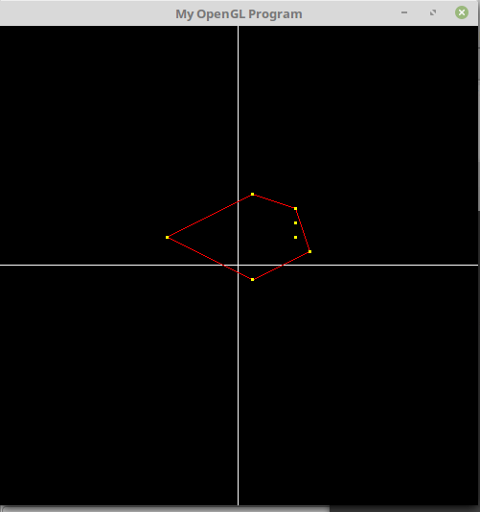

Graham Scan: $O(nlogn)$

Quick Hull: $O(n{}^{2})$

***Graham Scan* performs better than *Quick Hull*:**

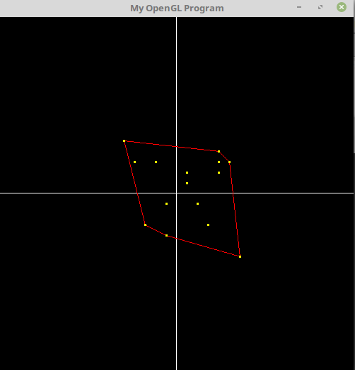

Graham Scan: $O(nlogn)$

Quick Hull: $O(nlogn)$